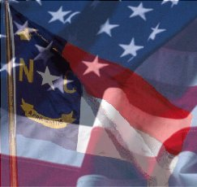

Scotland County Board of Elections

Buffer Zone for One-Stop Early Voting
2017 Municipal Elections
October 19 - November 4, 2017

The following is a description of the buffer zone concerning One-Stop Early Voting Electioneering. Buffer zone as designated by G.S. §163-166.4 (a)(a1), County Board of Elections, shall, where practical, set the limit at 50 feet from the door of entrance to the voting place, measured when that door is closed, but in no event shall it set the limit at more than 50 feet or at less than 25 feet. Area for Election Related Activity. – Except as provided in subsection (b) of this section, the county board of elections shall also provide an area adjacent to the buffer zone for each voting place in which persons or groups of persons may distribute campaign literature, place political advertising, solicit votes, or otherwise engage in election related activity.
Only individuals arriving for purpose of voting or an individual filing a challenge may enter this area. There shall be no campaigning or Electioneering inside the Buffer Zone area nor should anyone impede a voter’s access into this area.
The Buffer Zone and Electioneering Area will be marked during the One-Stop Early Voting period with:
Distance Marker Signs and Tape Stating – NO ELECTIONEERING

Polling Place: Location:
Scotland County Annex Building 231 E Cronly Street, Laurinburg, NC

The Electioneering Area will be set as
close as possible to the Buffer Zone
which is 50 ft. from the door on the
back of the building as set forth in
§163-166.4(a) (a1) (c).

